Review Date: 12/29/2021

#473 - Golden Potato Hot Dog Buns

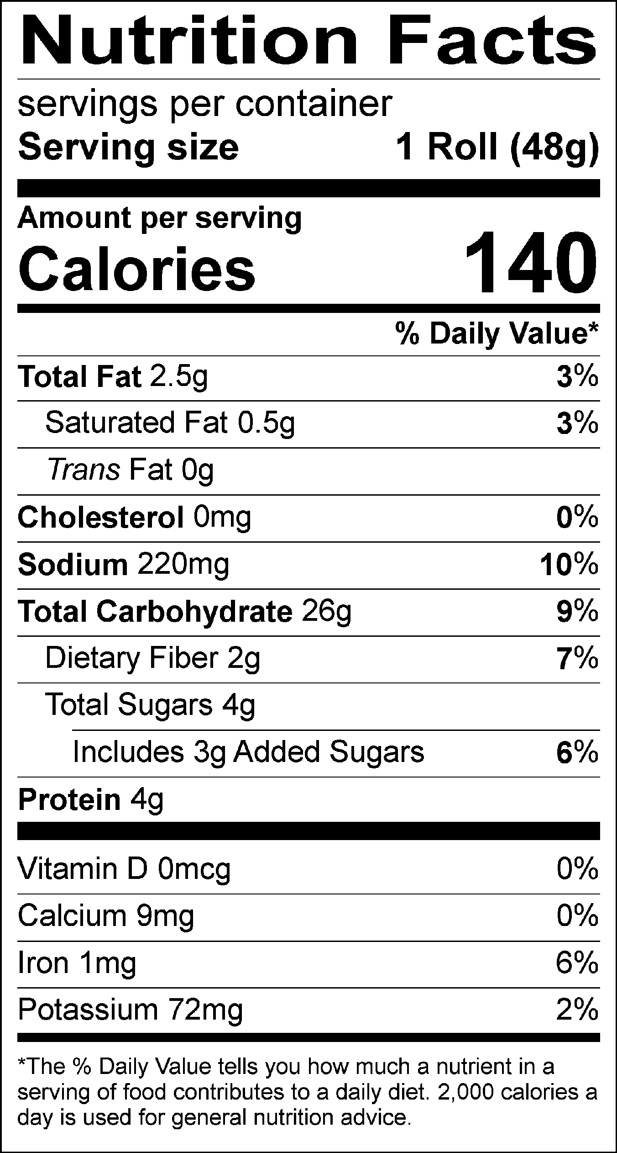
INGREDIENTS: ENRICHED WHEAT FLOUR (WHEAT FLOUR, NIACIN, REDUCED IRON, THIAMIN MONONITRATE, RIBOFLAVIN, ENZYMES, FOLIC ACID), WATER, SUGAR, SOYBEAN OIL, YEAST, POTATO FLOUR, SALT, DOUGH CONDITIONERS (SODIUM STEAROYL LACTYLATE, DATEM, MONO- AND DIGLYCERIDES, ETHOXYLATED MONO- AND DIGLYCERIDES, ASCORBIC ACID, POLYSORBATE 60, ENZYMES, L-CYSTEINE), WHEAT GLUTEN, YELLOW CORN FLOUR, TURMERIC EXTRACT COLOR, PAPRIKA EXTRACT COLOR, NATURAL FLAVOR, RYE FLOUR.

CONTAINS: WHEAT.

MANUFACTURED ON EQUIPMENT THAT PROCESSES MILK, EGGS, SOY.

CONTAINS A BIOENGINEERED FOOD INGREDIENT.

