Frozen Unbaked Rolls

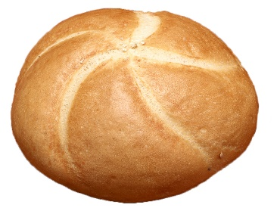
693 Jumbo Kaiser Rolls - FDF
INFORMATION









216 pcs | 2.75oz. | 10x5 | 8-12 hr | 30-35’ | 375-390 | 18-20’

HANDLING

- Pan as illustrated and place on rack in cooler to thaw overnight (not to exceed 12 hours).

- From cooler, dip in seeds if desired and place in proof box at 110 ºF and 90% humidity. Proof to twice their frozen size.

- Remove from proof box and place in oven at 390 ºF with steam. Bake for approximately 18-20 minutes. If steam is not available, water wash before baking.

- Remove from oven. Cool completely before packaging.

KEY ATTRIBUTES OF THE ITEM



